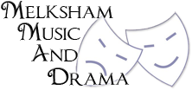

Membership Form
Please complete the following form to confirm your membership to MMAD.
All information will be kept for legal reasons and will be held by the club in accordance with our GDPR policy 2018. None of the information will be used in any way other than for the use of the Club.
Name

Address

Email address

Telephone number

Age and Date of Birth (Optional)

Declaration:

I agree to abide by all of the Clubs rules as set out in the constitution.

Signed:

If you are under the age of 16 this form must be signed by the adult who is responsible for you.
Signature of parent/guardian of the above member

The club believes in equal opportunity, if you require support or think that there is an issue that
the club should be made aware of please speak to a member of the committee.
I would like to speak to a committee member (Please tick)
Membership Number:

Date of Registration: Full Probationary

